Frenchs Forest Pre-poll runs for 2 weeks before Election day on 4th Dec 2021
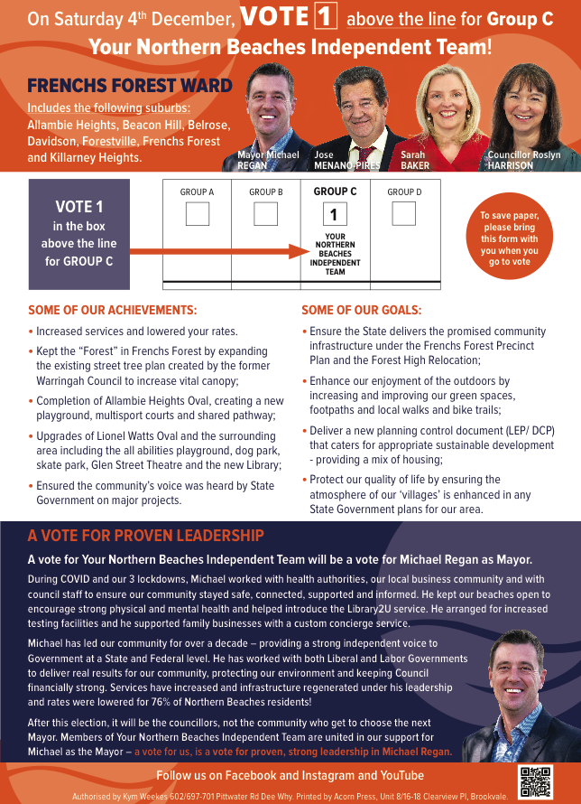
When: Monday 22 Nov 2021 - Friday 03 Dec 2021 9:00am - 5:00pm No Voting on Sundays.
Northern Beaches Returning Officer's Office Building B, Suite 6, 13 Narabang Way, Belrose NSW 2099

