Narrabeen Ward Pre-poll runs for 2 weeks before Election day on 4th Dec 2021
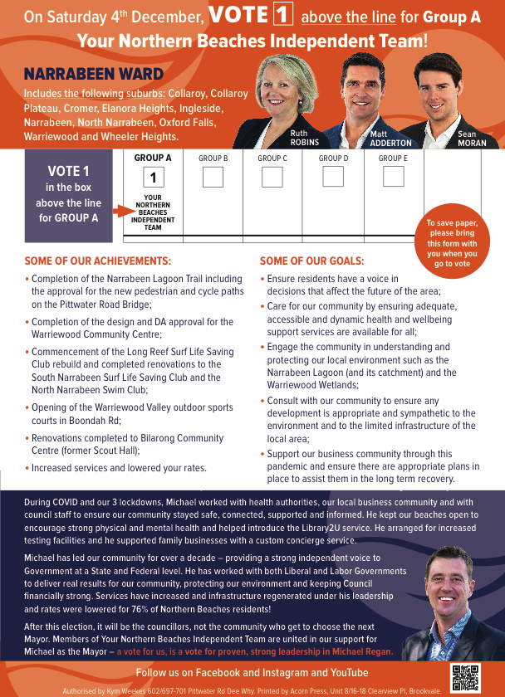
When: Monday 22 Nov 2021 - Friday 03 Dec 2021 9:00am - 5:00pm No Voting on Sundays.
South Narrabeen Surf Club ​ 1200 Pittwater Road, South Narrabeen NSW 2101
Mona Vale Memorial Hall Pittwater Road, Mona Vale NSW 2103

