Manly Ward Pre-poll runs for 2 weeks before Election day on 4th Dec 2021
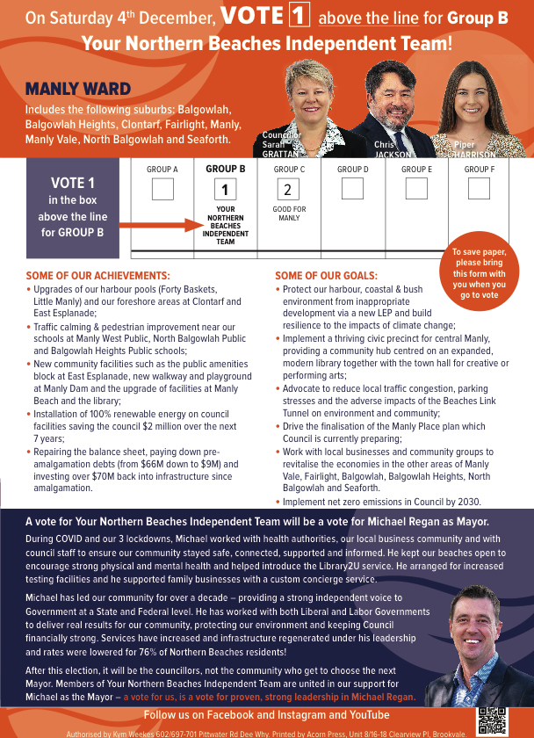
When: Monday 22 Nov 2021 - Friday 03 Dec 2021 9:00am - 5:00pm No Voting on Sundays.
St Matthew's Anglican Church, Manly 1 Darley Road, Manly NSW 2095

